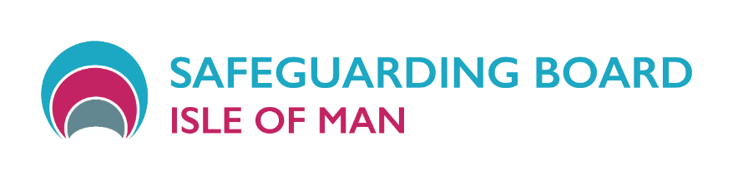
Training Schedule
Phase 1

May 2026 – November 2026

Dates | Subject – click hyperlink for further information | Level | Time of course
eLearn- available throughout year | Safeguarding Children Level 1 & 2 | 1 | n/a
eLearn- available throughout year | Safeguarding Adults Level 1 & 2 | 2 | n/a
26 June, 5 November | Child Protection Conferences and Core Groups | 3 | 09:30 – 16:00
12 May, 10 September | Professional Curiosity Workshop | 3 | 09:30 – 12:00
18 June, 9 October | Domestic Abuse 3 | 3 | 09:30 – 16:00
Dates TBC in June and November | Designated Safeguarding Lead | 3 | 09:30 – 12:30
22 May, 15 September | Threshold Guidance Workshops | 3 | 09:30 – 12:00
15 July, 7 October | Disabilities & Safeguarding | 3 | 09:30 – 16:00
Dates TBC in June, September & November | Self-Neglect | 3 | 09:30 – 16:00
9 July, 15 October | Capacity & Mental Health | 3 | 10:00 – 12:00
17 July, 16 October | Safeguarding from a Carers Perspective | 3 | 09:30 – 12:00
 | Booking Form | -

Safeguarding Children’s Competency Framework Safeguarding Adult’s Competency Framework

eLearn Safeguarding Children Level 1 & 2

Who delivers the training?
The eLearn Safeguarding Children Awareness courses have been developed by the Isle of Man Safeguarding Board in collaboration with representatives from organisations and departments from across the Isle of Man

Who is this training aimed at?
In reference to the Children's Competency Framework this training is for all staff who work regularly with children and young people and may be in a position to identify concerns. Level 1 & 2 entry levels are referenced in the competency framework.

How to access this training
To access this training you should-
- Send an email to safeguardingboardtraining@gov.im stating-
  - Your name
  - Your email address
  - The Level of Safeguarding Children training you require (Level 1 or 2)
- You will then be registered onto the course and will receive an email with a link inviting you to access the training.
- You can request access to undertake both Level 1 and 2 if you wish, this should be stated in your email that you send to safeguardingboardtraining@gov.im

The training is self-directed, does not have a time limit in terms of completion, and a certificate is automatically generated once you have passed the end of course test and completed a feedback form.
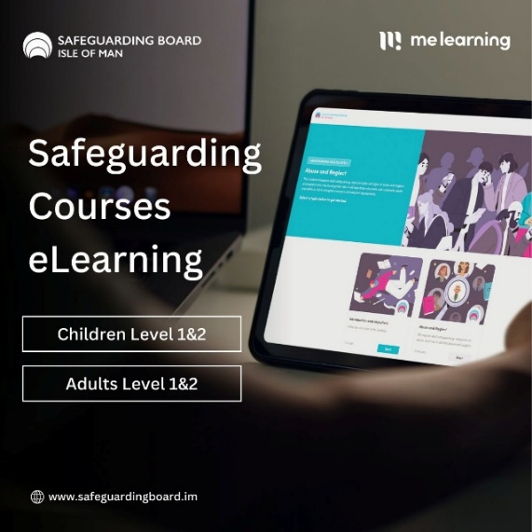

eLearn Safeguarding Adults Level 1 & 2

Who delivers the training?
The eLearn Safeguarding Children Awareness courses have been developed by the Isle of Man Safeguarding Board in collaboration with representatives from organisations and departments from across the Isle of Man

Who is this training aimed at?
In reference to the Adult Safeguarding Competency Framework this training is for all staff who work regularly with vulnerable adults and may be in a position to identify concerns. Level 1 & 2 entry levels are referenced in the competency framework.

How to access this training
To access this training you should-
  - Send an email to safeguardingboardtraining@gov.im stating-
      - Your name
      - Your email address
      - The Level of Safeguarding Adults training you require (Level 1 or 2)
  - You will then be registered onto the course and will receive an email with a link inviting you to access the training.
  - You can request access to undertake both Level 1 and 2 if you wish, this should be stated in your email that you send to safeguardingboardtraining@gov.im

The training is self-directed, does not have a time limit in terms of completion, and a certificate is automatically generated once you have passed the end of course test and completed a feedback form.
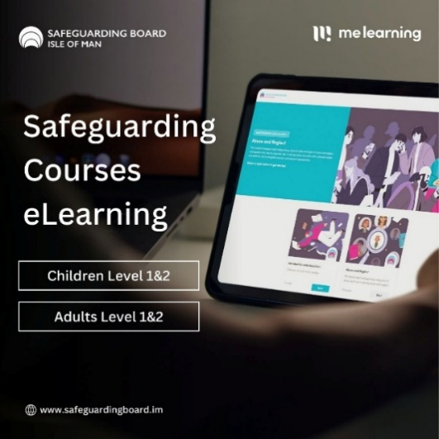

Core Groups & Child Protection Conferences Training Level 3

Who delivers the training?
The Independent Review Team, including the Children’s Rights Champion, run this day long course. This team Chair the child protection conferences and seek to equip professional to effectively understand and contribute to the child protection process.
Who is this training aimed at?
According to the children’s competency framework for safeguarding practitioners, this training is for Level 3 Staff. All staff working with children, young people and who could potentially contribute to assessing, planning, intervening and evaluating the needs of a child or young person and parenting capacity where there are safeguarding/child protection concerns, including S46 enquiries. E.g. Head Teachers/Designated teachers, GPs, Midwives, Health Visitors, School Nurses, CAMHS, Children and Families Social Workers, Education Liaison Officers, Police (MAPPU), Family Centre staff, Educational Psychologists, Children’s Ward Nurses, Residential and Secure Care Workers. If you are unclear about which level of training is suitable within your role then please read the children’s competency framework and speak with your line manager who should be able to help you.

What are the course aims?
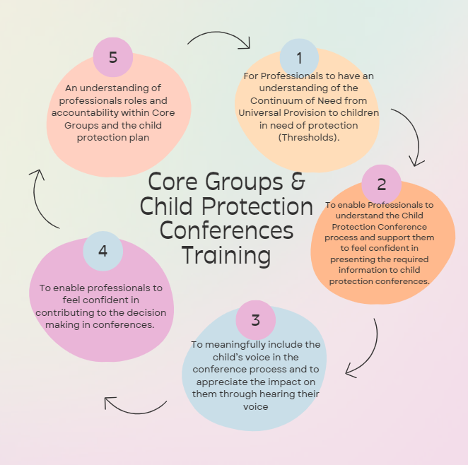

Professional Curiosity Workshop Level 3
This workshop is facilitated by;
A number of professionals from a multi-agency background (including health, IRT, education, social care, prison and probation) lead this half day session looking at professional curiosity

Who is this training aimed at?
Staff working with both children and/or vulnerable adults and who could potentially contribute to assessing, planning, intervening and evaluating the needs of a child and/or vulnerable where there are safeguarding concerns, including S46 enquiries. E.g. Head Teachers/Designated teachers, GPs, Midwives, Health Visitors, School Nurses, CAMHS, Children and Families Social Workers, Education Liaison Officers, Police (MAPPU), Family Centre staff, Educational Psychologists, Children’s Ward Nurses, Residential and Secure Care Workers.
What are the course aims?
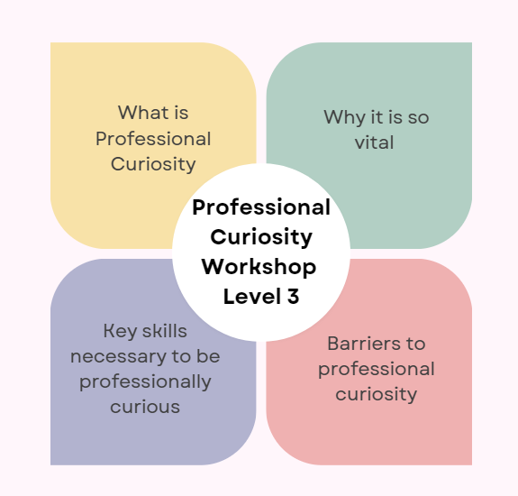

Domestic Abuse Training Level 3

Who delivers the training?
This course will be led by professional and practitioners from both statutory and third sector organisations
Who is this training aimed at?
According to our Children Competency Framework and the Adult Competency Framework; Level 3 practitioners include all registered Health and Social Care staff working with adults assessing, planning, identify interventions, and evaluate adult’s needs where there are safeguarding concerns. e.g. GP’s, MH Nurses, MH Social Workers, Residential Care Workers, Adult Social Workers, clinical Psychologist, clinical Psychiatrist, Dentist. Also, all staff working with children, young people assessing, planning, intervening and evaluating the needs of a child or young person and parenting capacity where there are safeguarding/child protection concerns, including S46 enquiries. E.g. Head Teachers/Designated teachers, GPs, Midwives, Health Visitors, School Nurses, CAMHS, Children and Families Social Workers, Education Liaison Officers, Police (MAPPU), Family Centre staff, Educational Psychologists, Children’s Ward Nurses, Residential and Secure Care Workers.
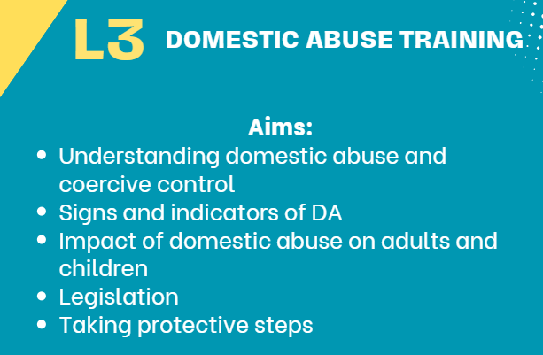
What are the course aims?

Designated Safeguarding Lead Level 3

Who is leading the Training?
Professionals within education, health & social care with extensive experience within their systems. The training is an interactive half day course. Venue confirmed upon booking.

Who is this training aimed at?
This training is essential for Designated Safeguarding Leads and their Deputies.

What are the course aims?
- To consider the key guidance and legal framework for Safeguarding.
- Identify the rationale for having a designated lead for safeguarding.
- List and explain the core responsibilities and scope of the safeguarding lead role.
- Describe the elements of a positive Safeguarding culture.
- Identify supports for managing challenges in the designated safeguarding role

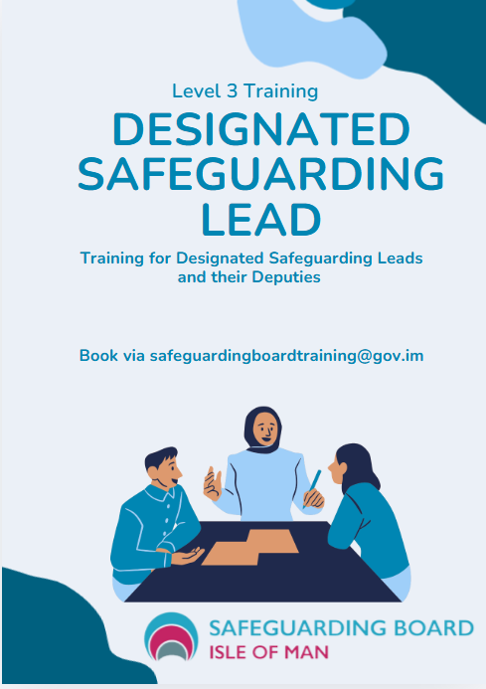

Threshold Workshops

Who is leading the Training?
Professionals within education, health & social care with extensive experience within their systems. The training is an interactive half day course.

Who is this training aimed at?
This training is essential for any professional or practitioner sharing the principles of the continuum of need and the threshold matrix to support understanding and confidence to inform the right level of support for children and families.

What are the course aims?
- To support the understanding of the threshold matrix and continuum of need using the new format for safeguarding children on the Isle of Man and how this is applied.
- To support practitioners in respect of information sharing and making decisions in respect of threshold.

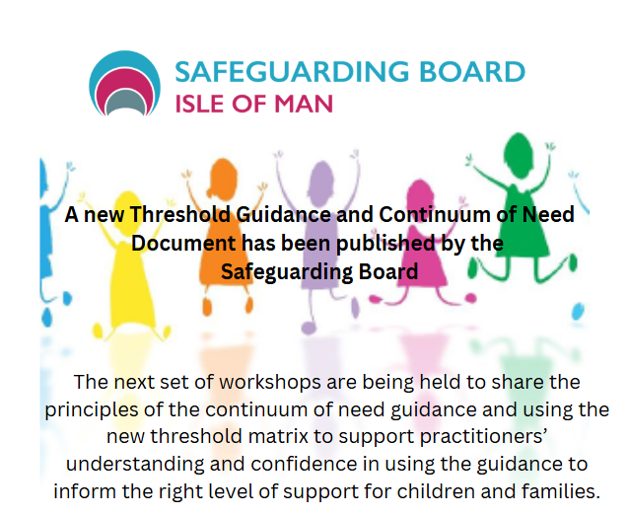

Disabilities & Safeguarding Level 3

This workshop is facilitated by
A number of professionals from a multi-agency background with extensive experience working in the field of disabilities both in the UK and the Isle of Man. This is a full day course.

Who is this training aimed at?
Staff working with both children and/or vulnerable adults who have disabilities. This will include learning disabilities, physical disabilities and those with dual diagnosis that includes neurodivergence (note- there will be a separate half-day workshop specifically on neurodivergence)

What are the course aims?

- Increase understanding of disability and vulnerability
- Highlighting the heightened safeguarding issues around disabilities
- Identifying and recognising indicators of abuse, neglect and exploitation
- Strengthening professional curiosity and risk assessment skills
- Improve communication and engagement
- Support multi-agency collaboration

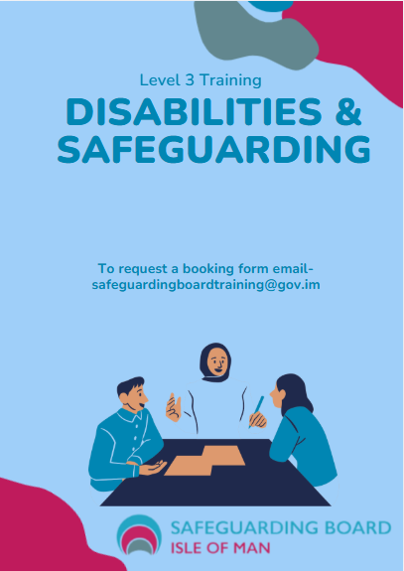

Self-Neglect Level 3

This workshop is facilitated by
A number of professionals from a multi-agency background with experience working in the field of self-neglect. This is a full day course.

Who is this training aimed at?
Professionals and practitioners working with vulnerable adults who may self-neglect.

What are the course aims?

- Exploring self-neglect- principles and values
- ‘Knowing/being/doing”
- Mutli-agency working and the self-neglect pathway
- Supporting professionals and practitioners for self-neglect practise

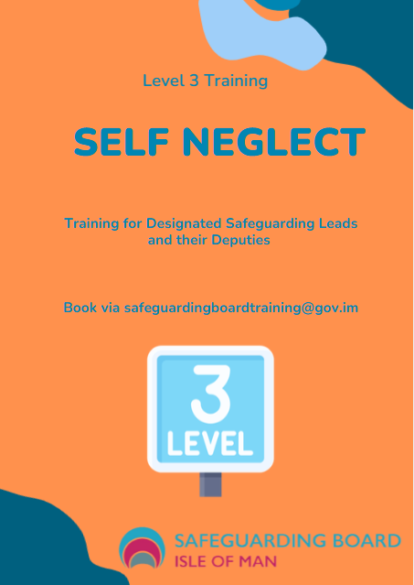

Capacity and Mental Health

This workshop is facilitated by
Led by Craig Nugent, a Social Worker and AMHP/ASW with expertise in mental health and capacity.

Who is this training aimed at?
Professionals and practitioners working with vulnerable adults in health and social care

What are the course aims?

- Capacity is an area that impacts on all health and social care matters but can remain a point of confusion among professionals and practitioners. This seminar looks to discuss best practice for capacity concerns, relevant case law, and the potential pitfalls for professionals to be aware of. Followed by Q&A session.

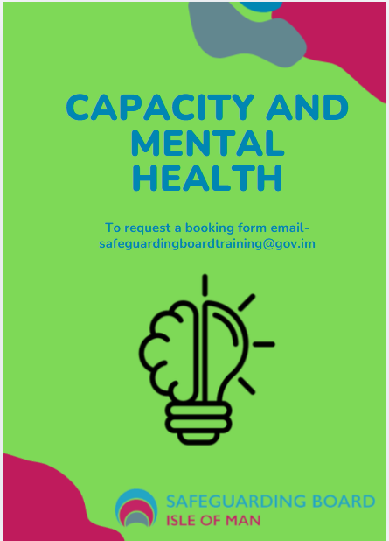

Safeguarding from carers perspective

This workshop is facilitated by
Professionals and practitioners from Adult Services and Crossroads

Who is this training aimed at?
Professionals and practitioners working with carers from all perspectives

What are the course aims?

- With the aim to raise awareness of the dilemmas and complexities of navigating safeguarding concerns within family settings, developing an understanding of when to intervene, and providing support to professionals to aid decision making. This will be an interactive session for professionals and practitioners.

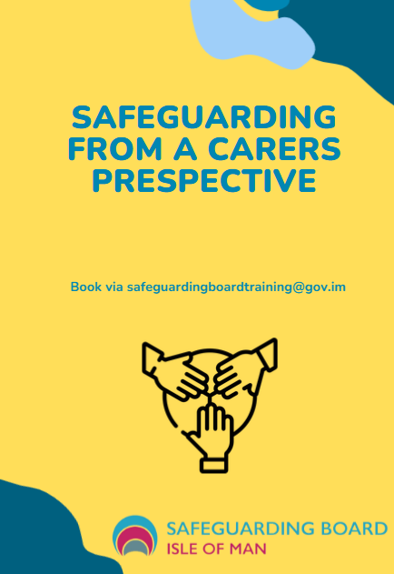

SAFEGUARDING BOARD
COURSE APPLICATION FORM 2025/2026

We are currently running a manual booking system for courses whilst we await our new online Training System. There will be firm criteria applied when considering any application made to ensure maximum impact of training is achieved across the partnership. Should courses be fully subscribed we will collate a waiting list and offer spaces to those colleagues who were unsuccessful at the time of application. We want to fairly allocate the availability across agencies.

In applying for the course you are also agreeing to being one of the 25% of attendees randomly selected to be contacted after 3 months for a short training impact interview. The IOMSB value feedback which we use to ensure our training remains relevant and demonstrates the impact of training on practice.

Please complete the following and return to safeguardingboardtraining@gov.im to apply for a place on the course.

A confirmation email will be returned to you.
Course Title:
Type:
Level:
Venue- please note, venue will be confirmed upon booking confirmation
Start & Finish Date & Time:

DELEGATES INFORMATION
Please complete with your information:
First Name:
Last Name:
Do you have any access requirements you would like us to be aware of?
Role:
Sector:
Organisation:
Email & Contact Tel No:

Reason for applying for a place on this course and aligned to the Boards Competence Framework:

Please gain authorisation from your Line Manager prior to application:
AUTHORISATION BY LINE MANAGER
In authorising this booking you are agreeing to the applicants’ attendance at training and a commit to supporting a reflective discussion on the impact of the training on their practice. Reflection helps to deepen the understanding of what was learned during the session and supports learning processes.
Line Manager Signature:
Line Managers Name in Full:
& Department:
Email & Contact Tel No:
Date:

Reason for applying for a place on this course and aligned to the Boards Competence Framework

