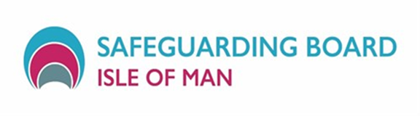

|  |  |
| --- | --- |
| **WORKING WITH SELF NEGLECT**  **A HALF DAY TRAINING EVENT** | |
| **DATES AVAILABLE**  **13TH December 2022 9.30 -12pm**  **13th December 2022 2pm – 4.30pm**  **14th December 2022 9.30 – 12pm**  **VENUE: The Sefton Hotel** | |
| The IOM Safeguarding Board is providing this free training to agencies across the IOM. Very sadly, some people from the IOM have recently died in circumstances of self-neglect. All agencies have a role to play in working together to reduce these risks and make a difference to people’s lives | |
| Learning Aims | * Develop awareness of self-neglect and some of the underlying causes * Understand what approaches are most successful in responding to self-neglect * To hear about learning from Serious Case management Reviews of people who have died in IOM in circumstances of self-neglect * To understand the policy and legal framework * To consider your role and responsibilities when working with people who are self-neglecting |
| How to apply | Apply to: [Safeguardingboard.co@gov.im](mailto:Safeguardingboard.co@gov.im)  Closing date: 25 November 2022 |
|  |  |